Phase Report of Sino-Danish Research Project: “Optimization of solar space heating & water heating combisystems in buildings”, 2010
Beijing Solar Energy Research Institute Co., Ltd.
- Budget and division of the research tasks
After the kick-off meeting for the project in July 2010, Beijing Solar Energy Research Institute Co., Ltd. (BSERI) finished the project budget declaring to the Chinese Ministry of Science and Technology. At present , the Chinese Agency has issued the project funds and paid to all participants.
According to the project working plans, the Chinese side is subject to undertake research as follows
- BSERI is responsible for the R&D of the flat-plate solar collector with covers, design, installation and monitoring of the solar demonstration system, and research of the numerical simulation and optimization of the solar heating system in cooperation with Beijing Institute of Technology.
- Beijing Institute of Technology is responsible for numerical simulation of the tank in solar heating system and the combisystem’s optimization in cooperation with BSERI.
- Beijing University of Chemical Technology is responsible for selecting and determining the phase change and energy storage materials, and detecting the materials properties.
- Project plans of Chinese side in 2010
  - R & D of solar collectors;
  - Investigation of heat store
- Project activities of BSERI in 2010
  - Analyze material of the Teflon film taken from Denmark, and measure solar transmittance of the Teflon film.
  - Design the structure of the double-cover flat-plate collector, and select the domestic supplier of Teflon films.
  - Conduct the Software training to Chinese researcher for future personnel exchange.
- Test results of the Teflon film
  - Solar transmittance measurement
Test organization: National Engineering Research Centre for Renewable Energy
- Sample 1#: the unused Teflon film taken from Denmark
The film’s solar transmittance is 0.950.
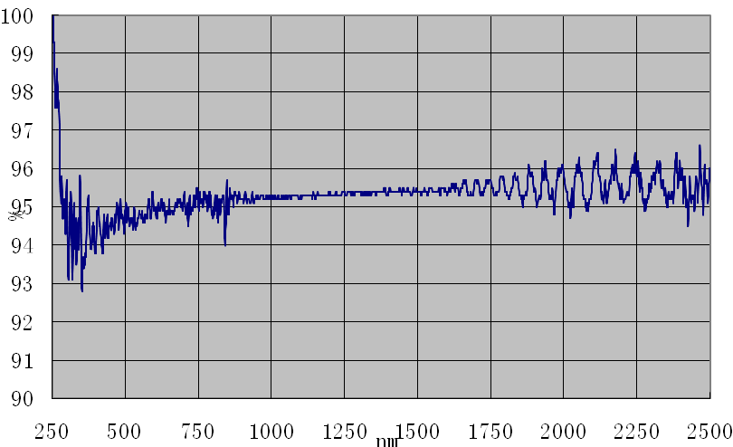
- Sample 2#: the Teflon film taken from the used flat-plate collector of Arcon Solvarme A/S, Denmark
The film’s solar transmittance is 0.925.
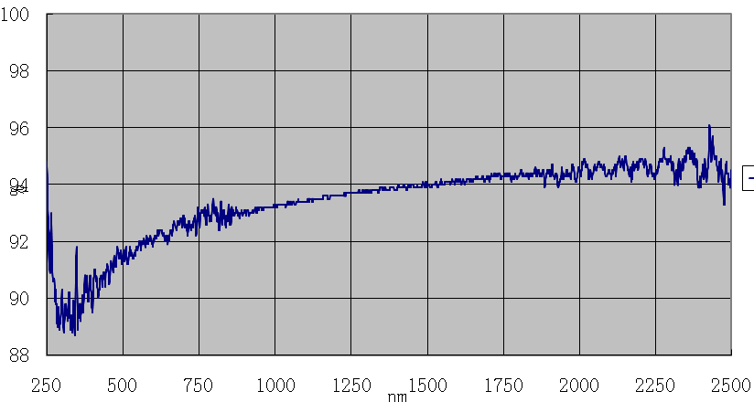
  - Composition and physical property test
Test organization: Beijing Center for Physical and Chemical Analysis
Composition of the Teflon film: Fluoroethylenepropylene (FEP)
Melting point of the Teflon film: 264℃
Film thickness: 0.026mm
- Project Plans of BSERI in 2011
  - 2011.1~2011.5 , R & D of flat plate solar collector with 2 covers;
  - 2011.4~2011.5, Researchers from BSERI go to Denmark to carry out numerical investigations and experimental investigations. 30days/2 persons;
  - 2011.4~2011.12, Investigation and optimization of system parameters on solar combisystems performance;
  - 2011.5~2011.9, Design and install demonstration system;
  - 2011.10~2011.12, System performance monitoring.
- Next video/audio meeting suggestion
I suggest that next meeting will be held in July and in Dec 2011.

Dunzhi Zhu
14. 12. 2010

